Avondale - Phoenix, Arizona
Avondale is a city submarket adjacent to Phoenix, AZ that has undergone rapid residential and commercial growth over the past two decades, with a population of 90,600 in 2023. This market has transformed from a small farming/rail-stop community to a mix of residential and commercial developments. The population has grown and the median household income was reported at $81,260 in 2023. Local growth in all sectors has diversified the economy, expanded job opportunities, and attracted young people – the median age is 32.4 years. These trends support continued growth in neighborhoods, business districts, and retail amenities.
Retail density manual count - 125
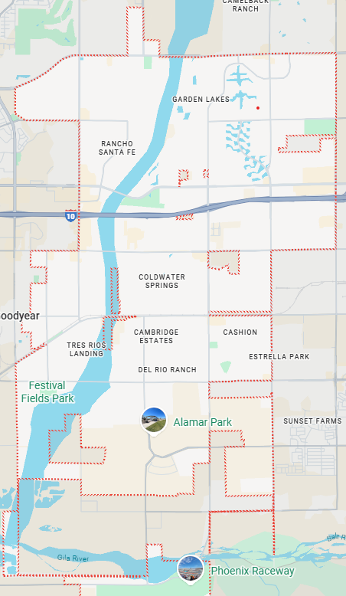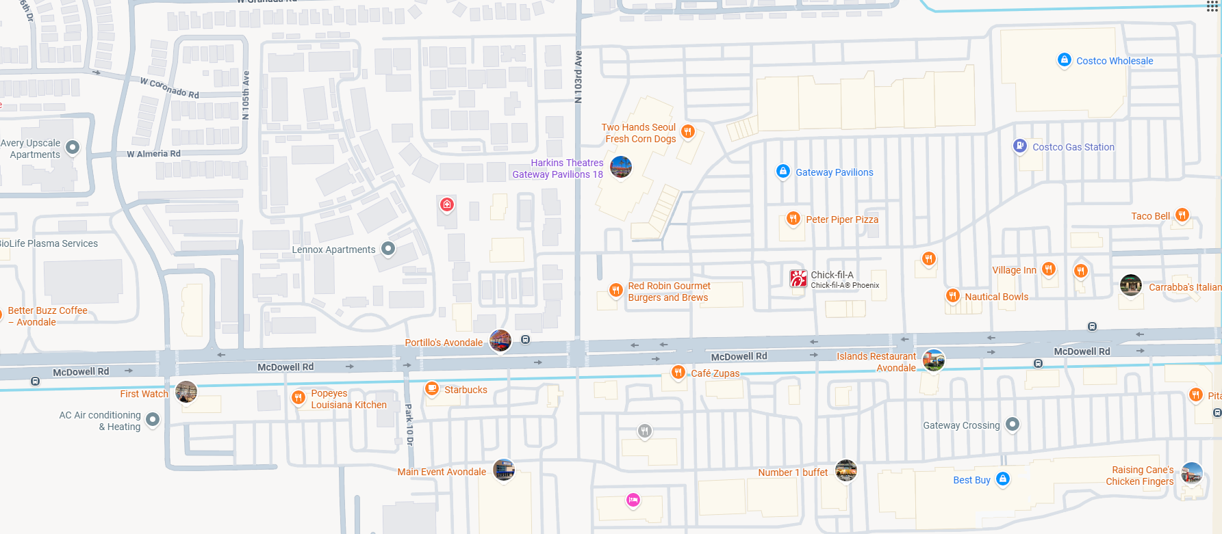
Source:
https://datausa.io/profile/geo/avondale-az?redirect=true

Lake Mary - Orlando, Florida

Lake Mary is a submarket of Orlando, FL positioned along the I-4 corridor with a population of 16,700 in 2023. It has grown steadily, been rated among the best places to live in Florida, and experienced strong commercial growth driven by tech, finance, and corporate relocations. The median household income was $116,944 in 2023. Outlook for business and retail growth is good, with available commercial real estate and room for expansion, regional market strength in the broader retail market, and public investment in infrastructure.

Retail density manual count - 200

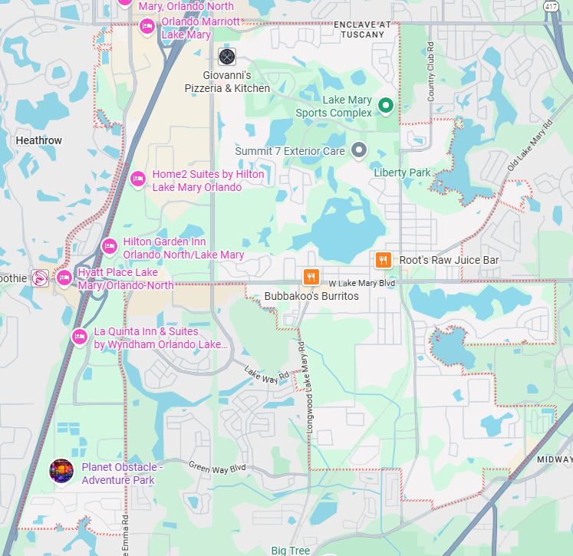
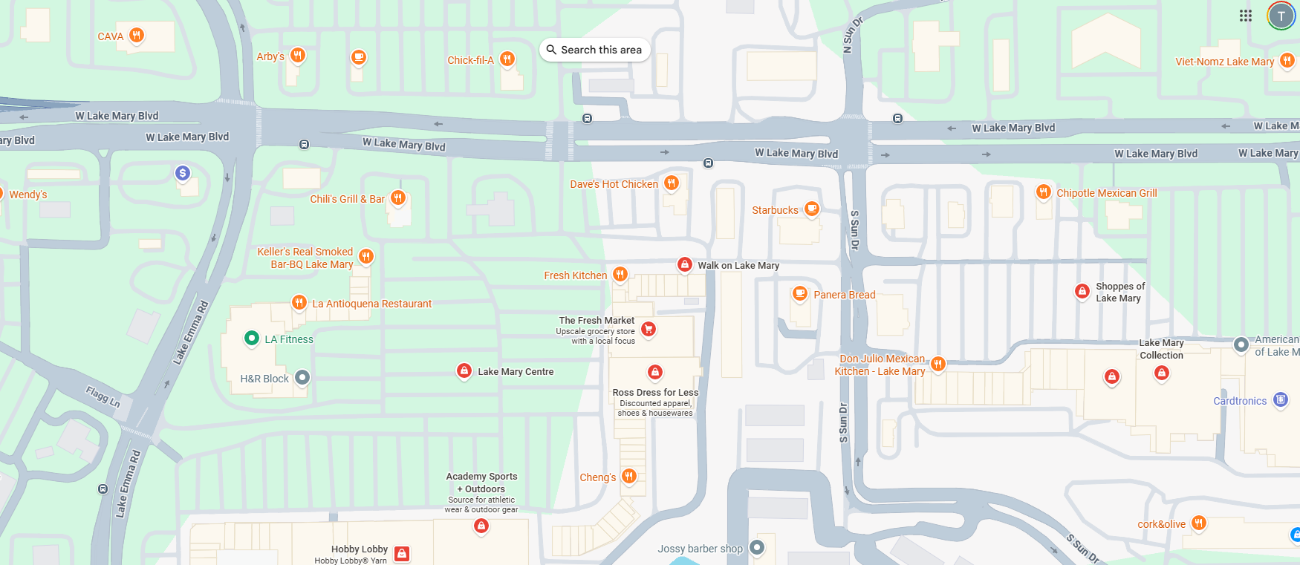

Source: https://datausa.io/profile/geo/lake-mary-fl
https://www.lakemaryfl.com/170/Lake-Mary---Where-Business-Thrives
Lake Nona - Orlando, Florida
Lake Nona is a mixed-use planned community submarket of Orlando, FL with a population of around 22,533 people per census estimates in 2023. Median household income is around $113,712. It is located off the Central Florida Greenway (SR-417). In addition to housing, the built environment is designed to support long-term business and community value as a modern “smart city.” Real estate values are rising, population is growing, and planned shopping/entertainment hubs are supporting growth in retail sectors.
Retail density manual count - 30
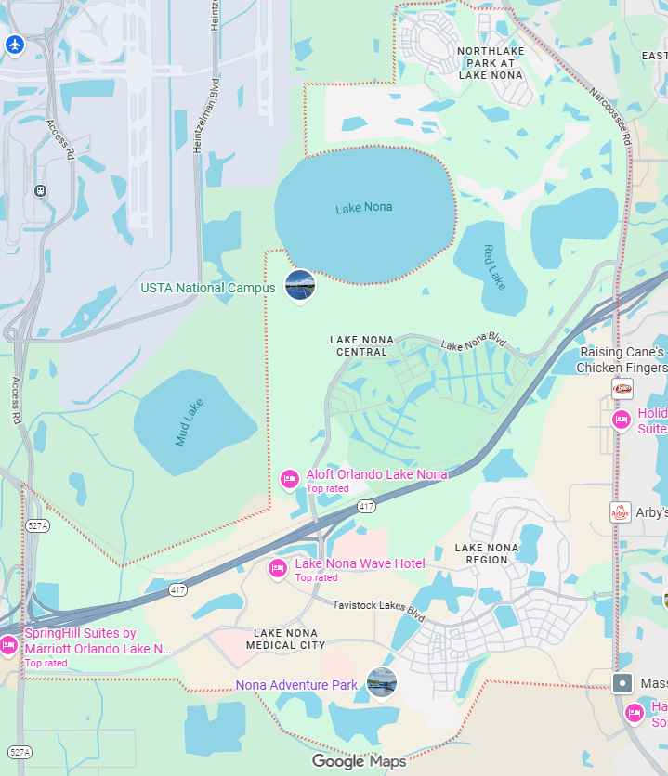
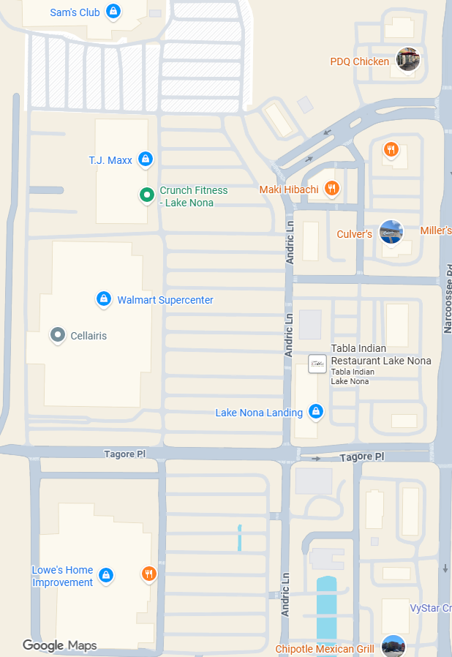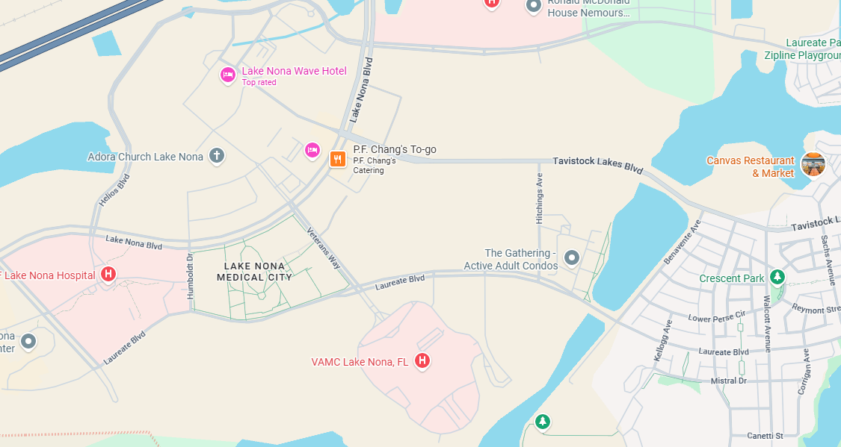

Source:https://lakenona.com/wp-content/uploads/2024/07/Lake-Nona-Fact-Sheet_Q22024.pdf
https://www.point2homes.com/US/Neighborhood/FL/Orlando/Lake-Nona-Demographics.html

Sandy Springs - Atlanta, Georgia
Perimeter area, zip code 30328

Sandy Springs is a northern submarket of metro Atlanta, GA with a population of 107,198 in 2023. The perimeter area of Sandy Springs, zip code 30328, is the business and commercial core of the submarket, with a population of 38,821 in 2023. It centers around Perimeter Mall, 1-285 and GA 400 and is a hub for corporate headquarters. The average household income is one of the highest in the region around $101,593. However, the area is nearly “built-out,” so growth opportunities will consist of smart redevelopment and repurposing of existing properties in a steady but selective growth pattern. This means demand for flexible commercial real estate is likely to increase, and sectors with structural growth, including retail, are likely to dominate.

Retail density manual count - 100

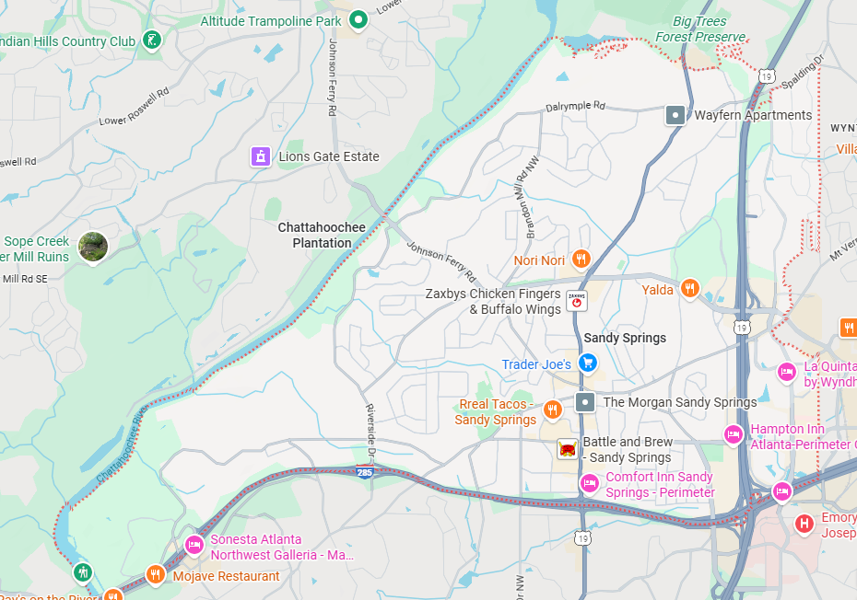

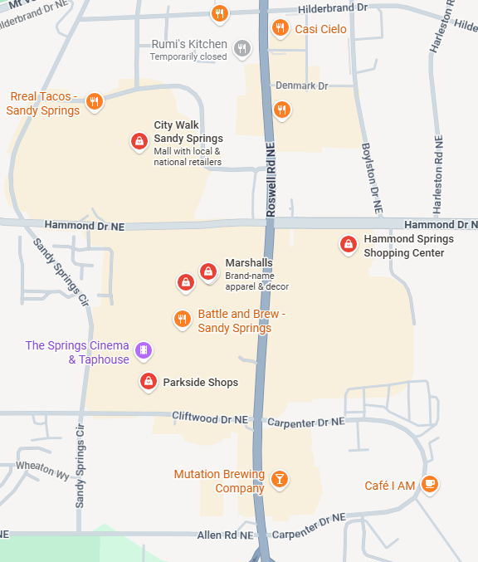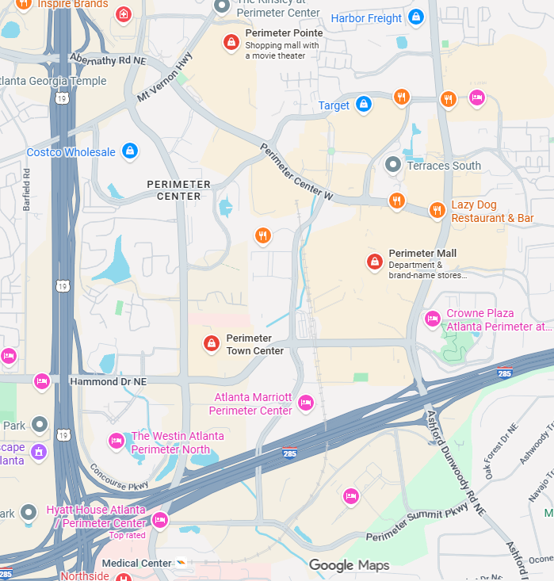

Source: https://datausa.io/profile/geo/sandy-springs-ga
https://www.sandyspringsga.gov/location-advantages
Princeton - Dallas, Texas

Princeton is a rapidly growing submarket city north of Dallas, TX with a population of 28,027 in 2023. As of this year, it is considered to be the fastest-growing city in the United States, with population surging by 30% in one year. Median age is young, 33.2 years old, and median household income is $90,809. New housing construction is booming, and with so many new residents, there is tremendous demand for everyday retail, along with available land for business and commercial growth.

Retail density manual count - 50

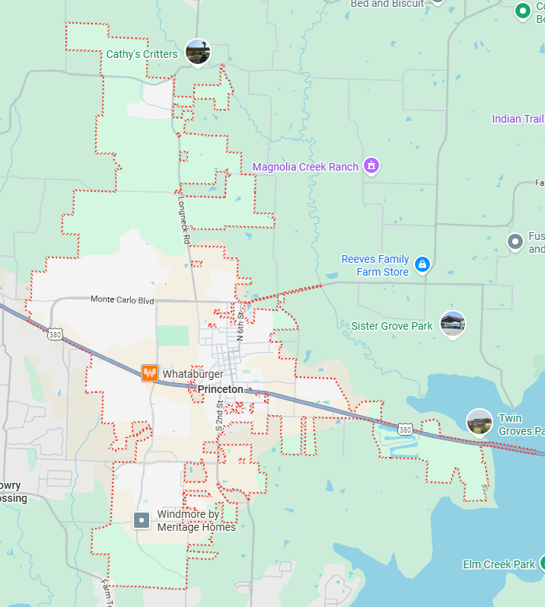
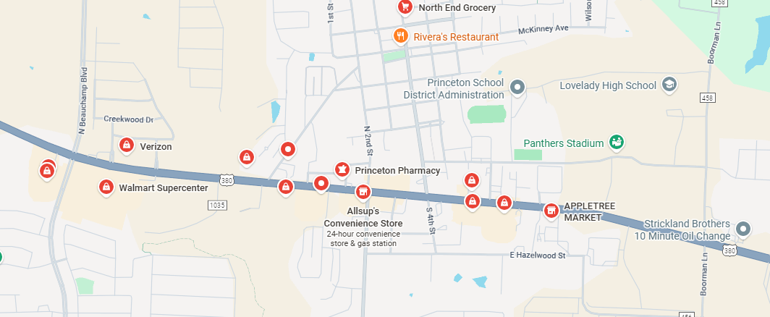

Source: https://princetontx.gov/303/Princeton-Demographics
https://www.princetontx.gov/CivicAlerts.aspx?AID=433

